***Directions:*** Complete the Questions below (10 points each). Display a snippet of the code and the output below:

**COP2335: Object-Oriented Programming Lab 9**

1. Write a program that asks the user for the name of a file. The program should display the first ten lines of the file on the screen (the “head” of the file). If the file has fewer than ten lines, the entire file should be displayed, with a message indicating the entire file has been displayed.

**Snippet of the Classes:**

**Snippet of the Output:**

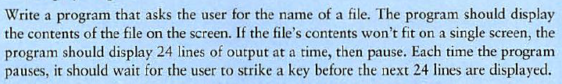

**Snippet of the Classes:**

**Snippet of the Output:**

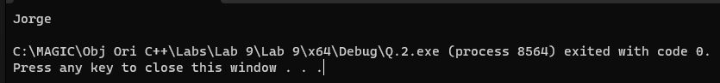

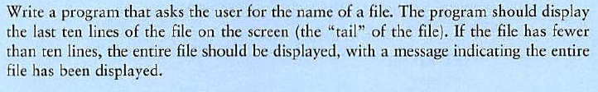

**Snippet of the Classes:**

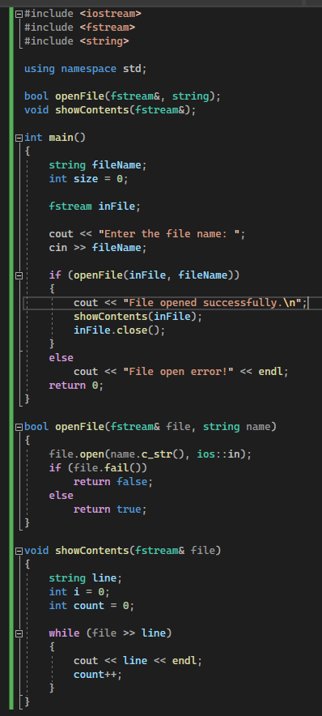

**Snippet of the Output:**

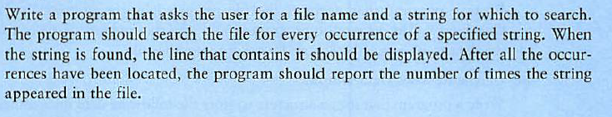

**Snippet of the Classes:**

**Snippet of the Output:**

